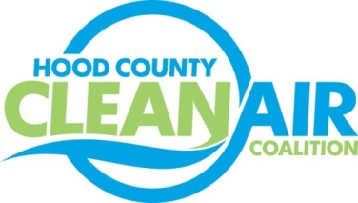
Meeting: Thursday, April 6, 2017
Neely House
304 East Rucker Street, Granbury, Texas 76048
8:30-10:00 a.m.

Agenda
- Call Meeting to Order
- Executive Session
- Annual Officer Elections
- EPA Updates – Randy Pitre
- Regional Updates – Michelle McKenzie
  - Air Quality Funding Opportunities: www.nctcog.org/aqfunding
i.) Upcoming EPA Grant
ii) Propane Council of Texas
iii.) Group Purchase Opportunity for Alternative Fuel Vehicles (Propane, Electric, and Plug-in Hybrid Vehicles)
  - Conformity Schedule
  - Volkswagen Mitigation Update
  - Air Quality Update
  - Compressed Natural Gas Station Safety and Inspection Training
  - Alternative Fuel Vehicle Day Odyssey Summit – Thursday, April 20th at Fair Park in Dallas
  - Air North Texas
    - New website: www.airnorthtexas.org
    - Clean Air Action Day – June 23, 2017: www.airnorthtexas.org/cleanairactionday
- Local Updates – Michelle McKenzie
  - Review of March Meeting Summary
  - Review of Projects
    - Monthly Budget Review for February
    - Status of Projects FY 16/17
    - Review of Proposed Budget for FY 18/19 Proposal for Grant Activities
7.) Discussion
8.) Adjourn

